2303a51830
Lab assignment-12.3

Task 1: Sorting Student Records for Placement Drive
Scenario
SR University’s Training and Placement Cell needs to shortlist candidates
efficiently during campus placements. Student records must be sorted by
CGPA in descending order.
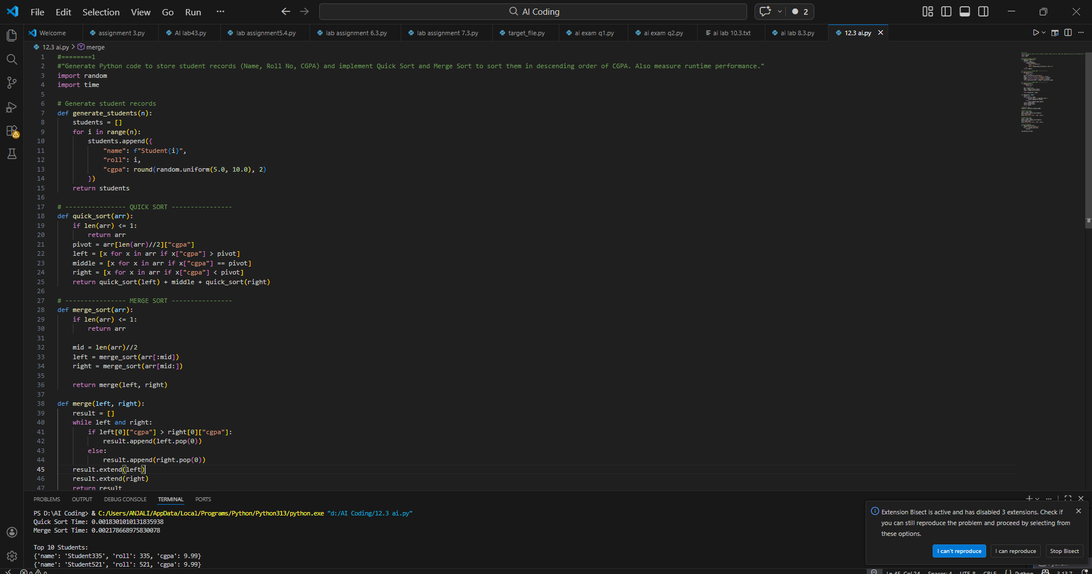
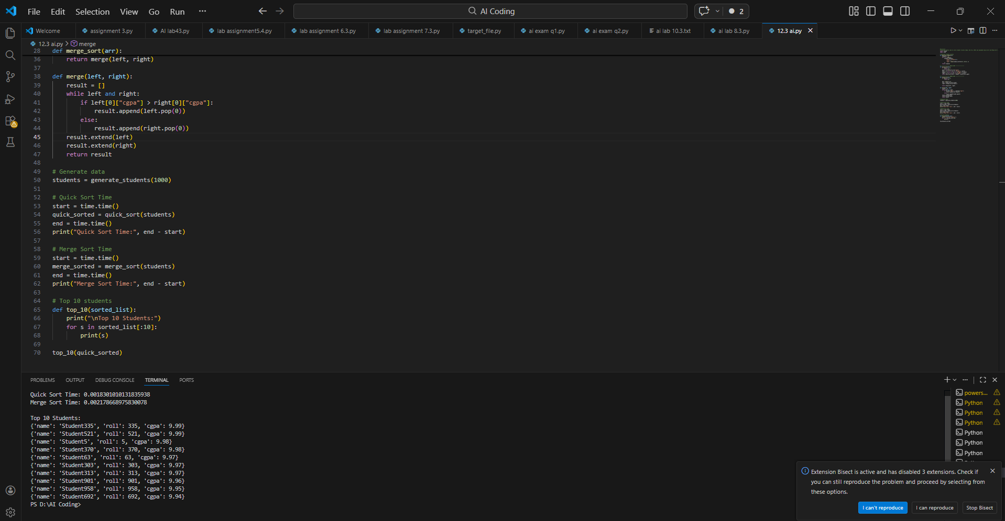
Task 2: Implementing Bubble Sort with AI Comments
• Task: Write a Python implementation of Bubble Sort
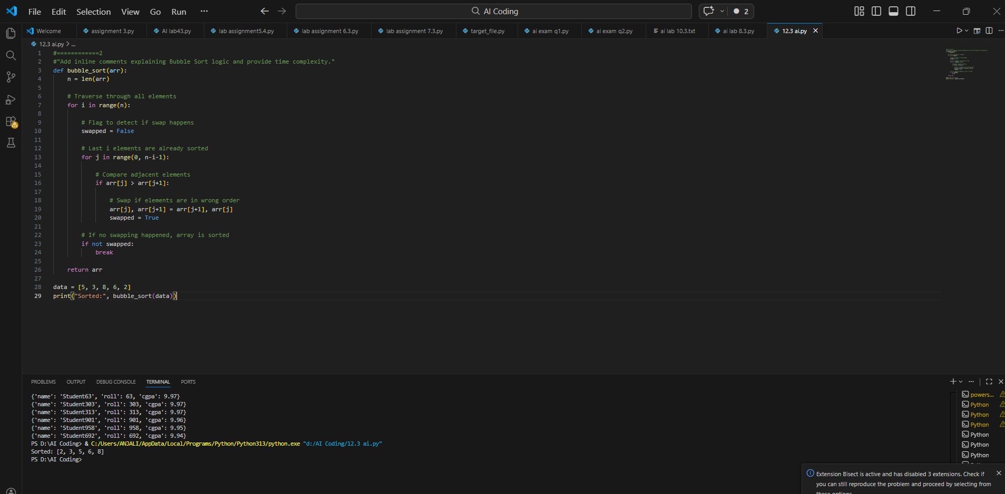

Task 3: Quick Sort and Merge Sort Comparison
• Task: Implement Quick Sort and Merge Sort using recursion
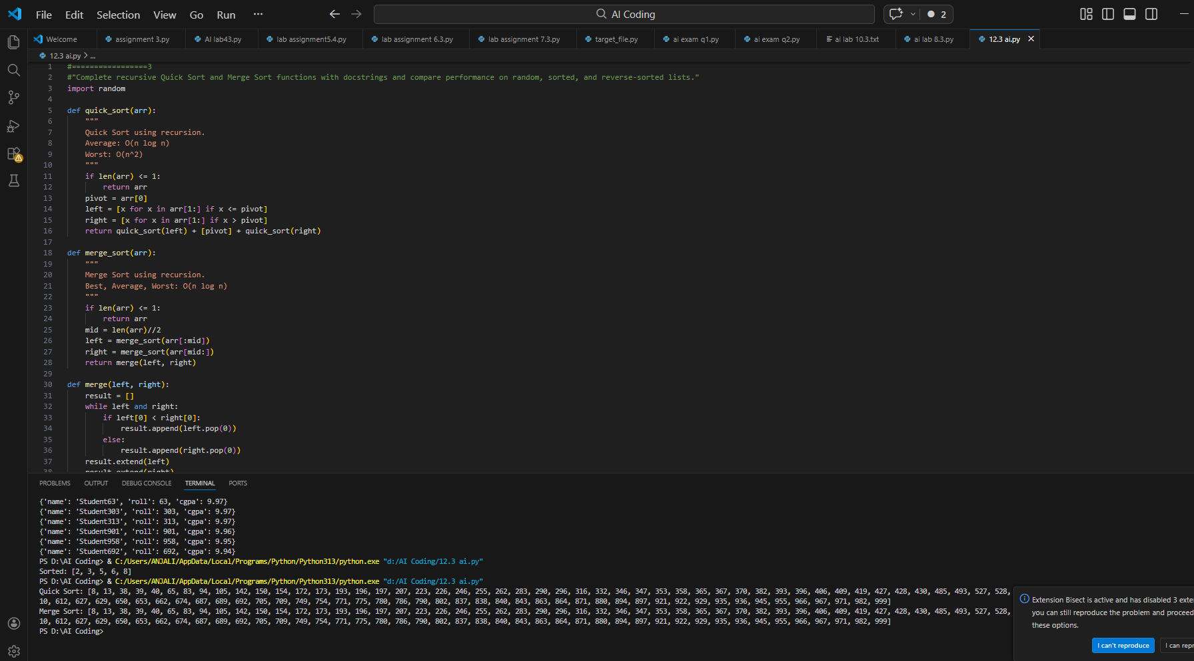
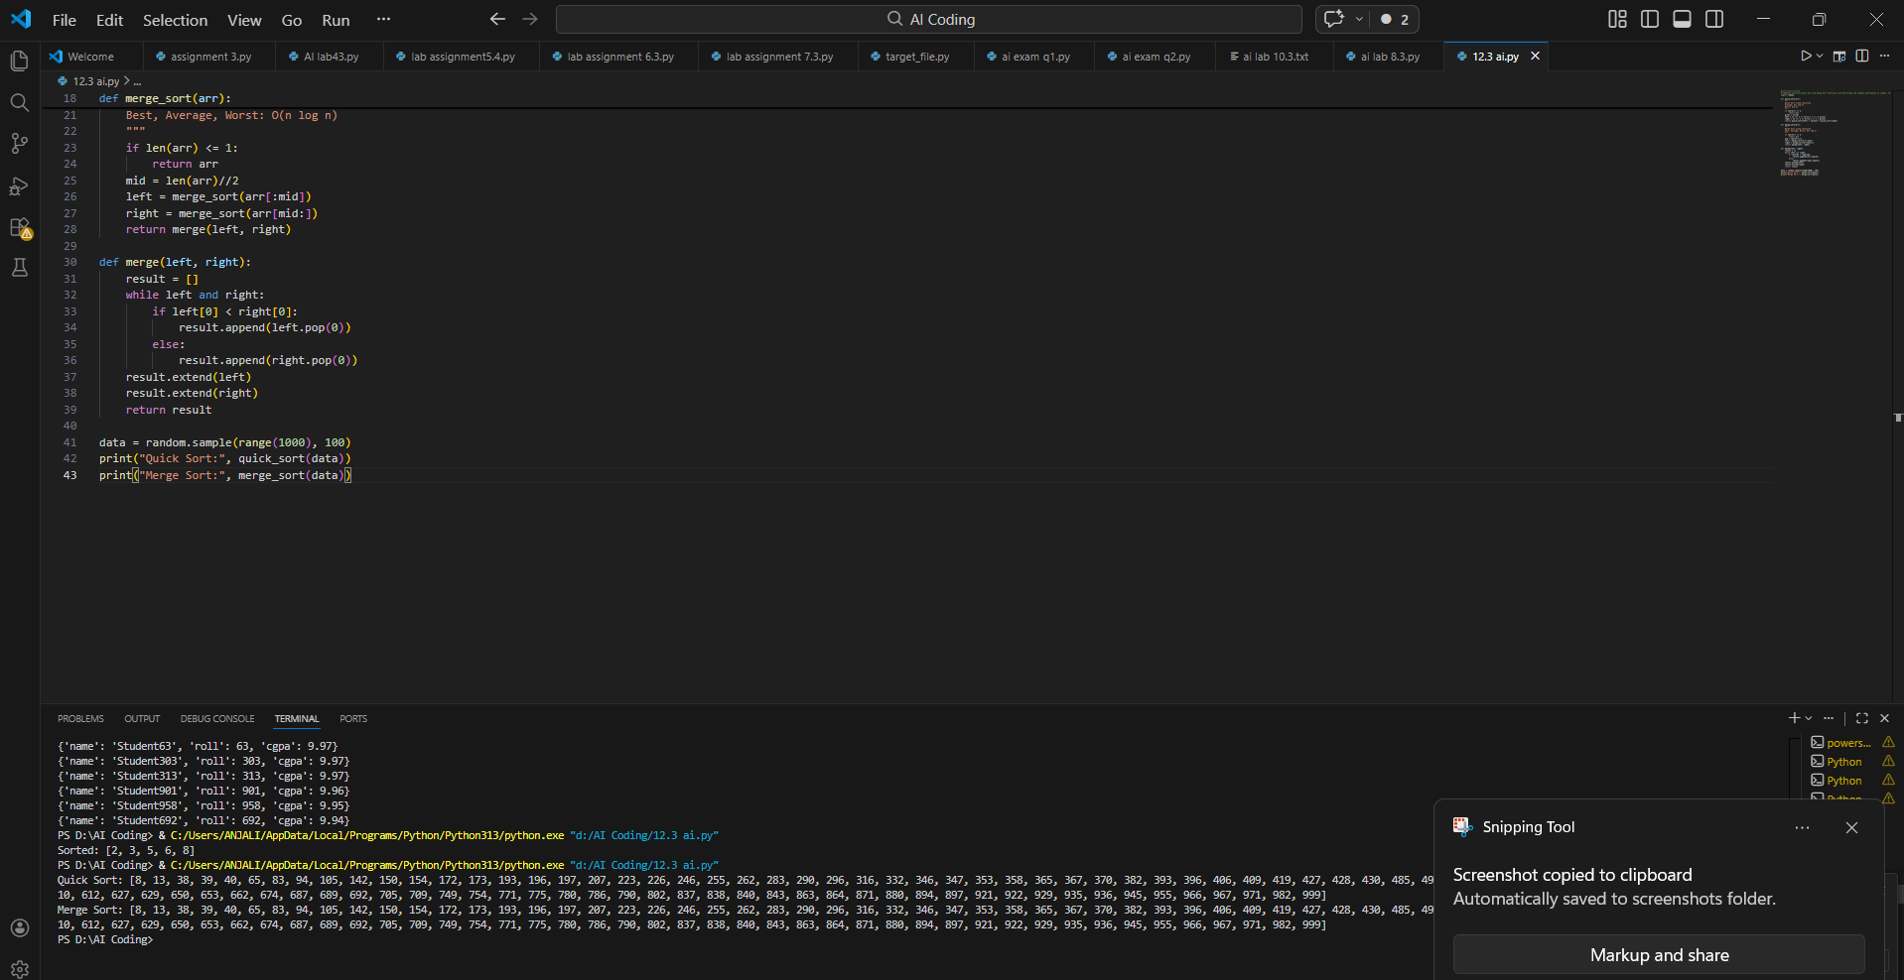

Task 4 (Real-Time Application – Inventory Management System)
Scenario: A retail store’s inventory system contains thousands of products,
each with attributes like product ID, name, price, and stock quantity. Store staff
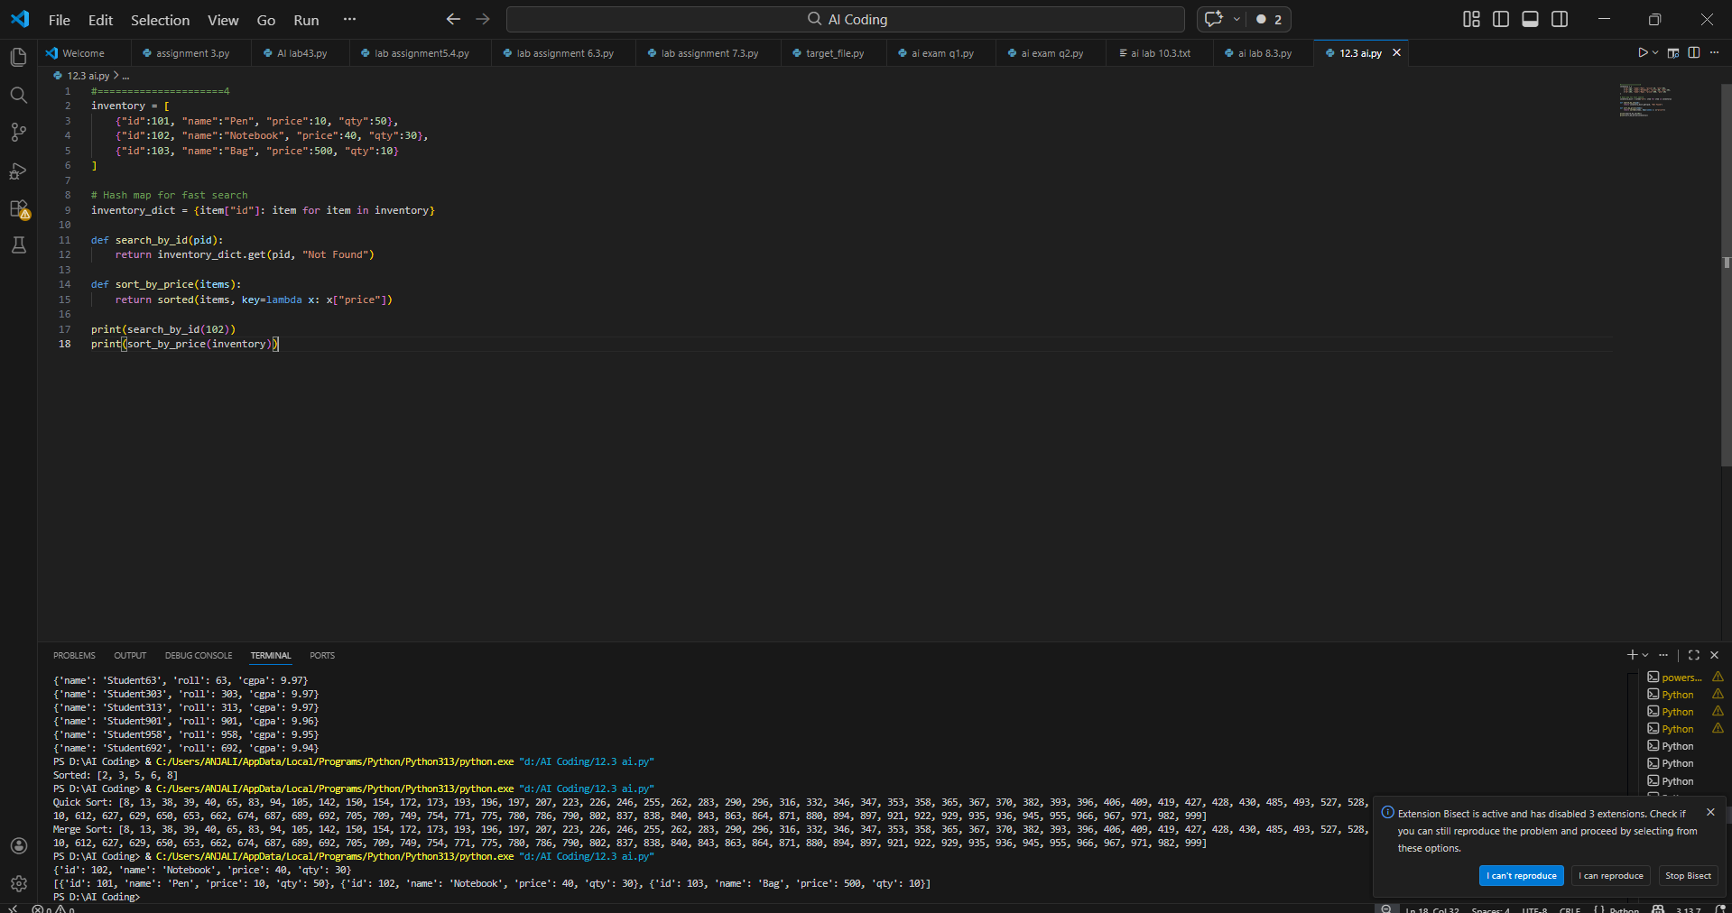

Task 5: Real-Time Stock Data Sorting & Searching
Scenario:
An AI-powered FinTech Lab at SR University is building a tool for analyzing
stock price movements. The requirement is to quickly sort stocks by daily
gain/loss and search for specific stock symbols efficiently.
